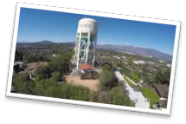
Become a Sponsor Today!
Complete the following form and please mail the form with a check to:
South Pasadena Prayer Breakfast
P.O. Box 3598
South Pasadena, CA 91031
Individual Name Business / Organization
How You Wish to Be Acknowledged

Legacy Sponsor Level: $1,000
Partner Sponsor Level: $500
Companion Sponsor Level: $250
Friend Sponsor Level: $100
Other Sponsor Level:
Amount of Your Donation
Address___________________________________________________________________City ___________________________________State ______ Zip ____________________ Phone ________________________________Email_______________________________

As of now we are just receiving checks. Please contact our Treasurer, Elizabeth Dever, if you require a different form of payment at (213) 842-0229.

Thank you so much for your meaningful support!

